**Transparent HiFi Audio Amplifier for Headphones**

**Abdullah Khan – 0026047493**

**Team # 3 – Alpha Team**

**Section # 4**

**10/20/2016**

**Power Amplifier**

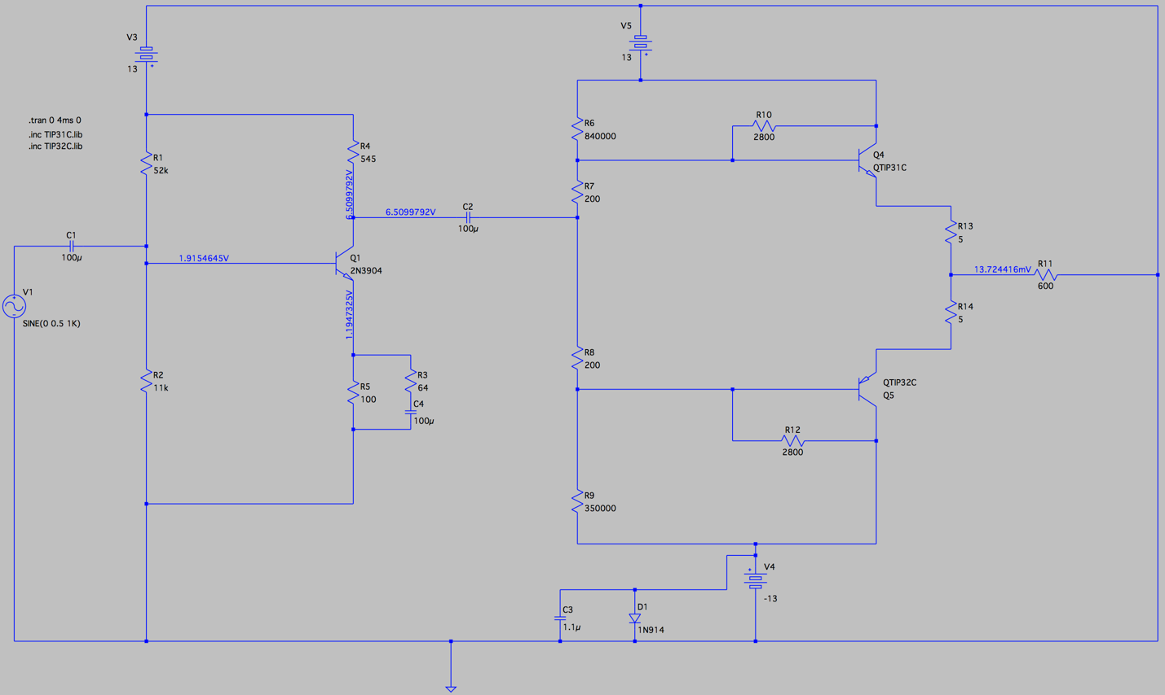**Detailed Schematic**

Abdullah Khan – Team # 3 – Power Amplifier

10/19/2016

Fig. 1 – Schematic of Power Amplifier

**Subsystem Block Diagram**

**2\***

**1\***

Abdullah Khan – Team # 3 – Power Amplifier

11/16/2016



Fig. 2 – Subsystem Block Diagram for right channel

* **1* -** Please refer to **Fig. 3** & **Fig. 6** to see amplified results for different headphone impedances.
* **2* -** Please refer to **Fig.4** & **Fig. 7** to see results from Power amplifier for different headphone impedances.

**Strategy Document**

The power amplifier subsystem will get a 1 V pk-pk signal input from the Amplifier controls subsystem and will amplify that to output analog audio signal across various headphones. All parts of the subsystem will be powered by +13/-13 DC Voltage signal. The subsystem consists of two different parts to achieve amplification of both current and voltage.

The first stage of the design consists of a preamplifier design. This is essentially a Class A audio amplifier which is implemented in order to boost the voltage of the 1 V pk-pk signal that the subsystem receives as input. A major design consideration that has been made here revolves around amplifying voltage to the adequate level while maintaining low noise in the signal. The design consists of two biasing resistors followed by a NPN transistor. This part of the design is powered by a +13V DC power rail. The output for the Pre-Amplifier stage can be seen in **Fig. 3** which shows a 1 V pk-pk signal being amplified to the required voltage. This is also consistent with the simulation results that I have for the preamplifier stage.

The next step of the design consists of the power amplifier which amplifies the current. This part of the subsystem is required to have enough current in order to drive the output across the headphones. A class AB amplifier design has been implemented here in order to achieve the adequate current amplification. This design also consists of two biasing resistors for each transistor and is powered by +/- 13V DC power rails. The output for the Power Amplifier stage can be seen in **Fig. 4** and is consistent with the simulation results produced.

Currently the design supports all headphone impedances and to show this I have tested it with the 16Ω and 600Ω impedances. The design also has low noise and this is shown in **Fig. 5** by FFT analysis where there is only one major peak which shows there is little distortion. Results shown in **Fig. 6**, **Fig. 7** and **Fig. 8** demonstrate working at different headphone impedance from the ones shown previously for the Pre-Amplifier, Power Amplifier and the FFT analysis.

The power amplifier must have as slew of >3V/μs using a 10kHz square wave near full output at 600Ω; the result is shown in **Fig. 9** which shows a slew of 9V/μs.

The design works with different input frequencies and has been tested with 300 Hz, 1 KHz and 15 KHz; refer to **Fig. 10**, **Fig. 4** and **Fig. 11** respectively.

The design meets the requirement of DC offset being less than 20mV during operation and is measured right before R11 (refer to schematic) to verify funcionality.

To calculate the output impedance, the following formula will be used to make sure specification is met and is less than 2Ω:

Output Impedance = 1 / gm + R13 = VT / IEQ + R13

= 0.025 / 0.0545 + 1 = 1.459Ω (assuming R13 is 1Ω instead of 5Ω)

Results for THD attached in **Fig. 15** and show most requirements met.

**Oscilloscope Evidence - 600Ω Headphone Impedance**

**Pre-Amplifier**

Input Signal

Output Amplified Signal

Fig. 3 – Output for Pre-Amplifier Stage

**Power Amplifier**

Input Signal

Output Amplified Signal

Fig. 4 – Output for Power Amplifier Stage

**FFT Analysis**

FFT Analysis

Output Amplified Signal

Fig. 5 – FFT Analysis of Output wave from Power Amplifier Stage

**Oscilloscope Evidence - 16Ω Headphone Impedance**

**Pre-Amplifier**

Output Amplified Signal

Input Signal

Fig. 6 – Output for Pre-Amplifier Stage

**Power Amplifier**

Input Signal

Output Amplified Signal

Fig. 7 – Output for Power Amplifier Stage

**FFT Analysis**

FFT Analysis

Output Amplified Signal

Fig. 8 - FFT Analysis of Output wave from Power Amplifier Stage

**Slew Rate – 600Ω Headphone Impedance**

Output Amplified Signal

Fig. 9 – Output slew rate ~9V/μs

**Results at different frequencies – 600Ω Headphone Impedance**

Output Amplified Signal

Input Signal

Fig. 10 – Output of Power Amplifier at 300 Hz Frequency



Output Amplified Signal

Input Signal

Fig. 11 – Output of Power Amplifier at 15 KHz Frequency

**THD Results**



Fig. 15 – THD Results

**Prototype**

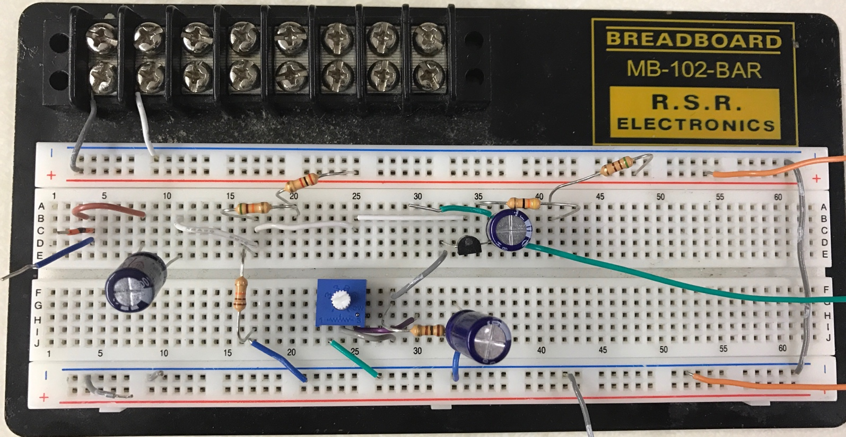**Pre-Amplifier**

**Bias Resistors**

**Output to 2nd Stage**

**Input Signal**

**NPN Transistor**

Fig. 12 – Pre-Amplifier

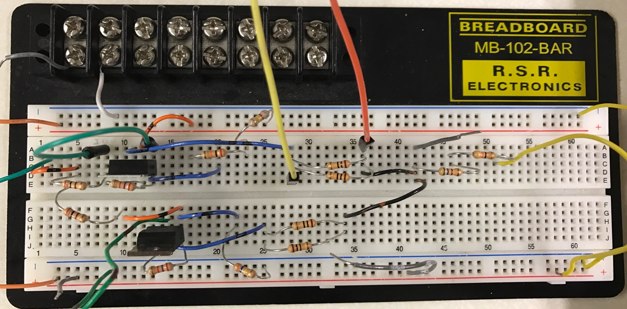**Power Amplifier**

**Output Signal**

**PNP Loop**

**NPN Loop**

Fig. 13 – Power Amplifier

**Complete Design**

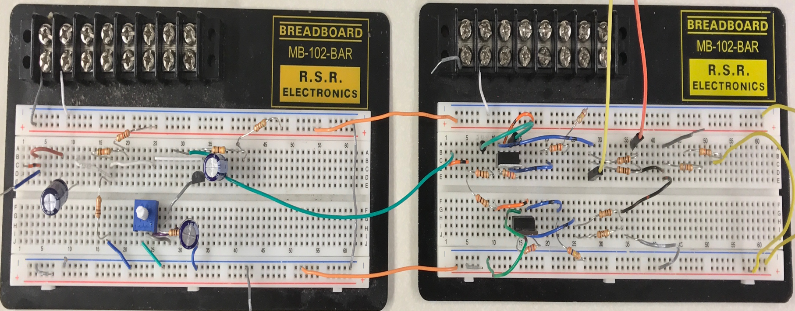

Fig. 14 – Complete Design